5/17/2021

Abdelrahman Adel

Abdelrahman.adel.elsayed@gmail.com

AI Diploma

Assessment Six

Contents

Task one: 2

Task Two: 3

Task Three: 4

# Task one:

Scrapping the first five articles from <https://coreyms.com/>, and saving the results to csv file.

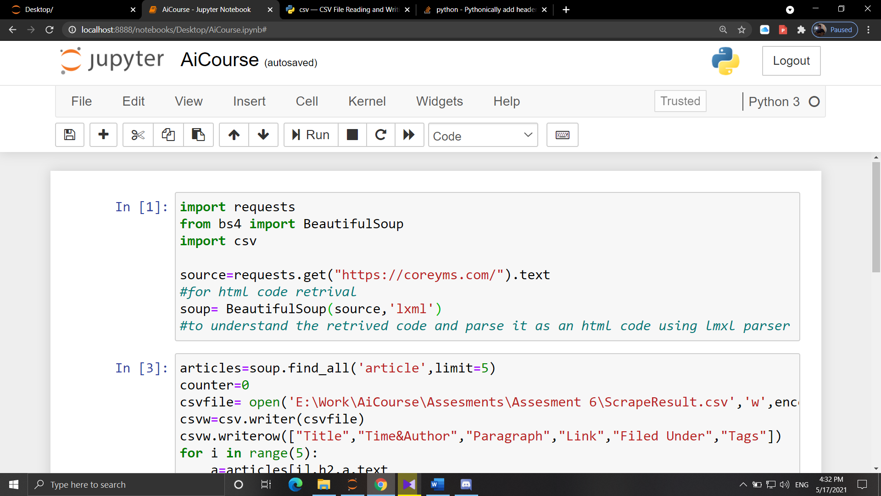

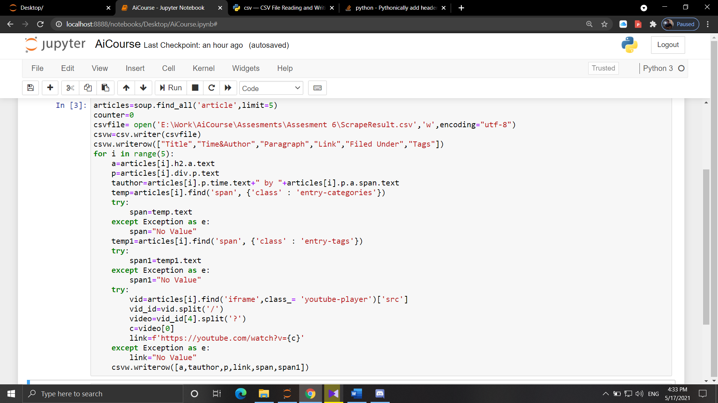

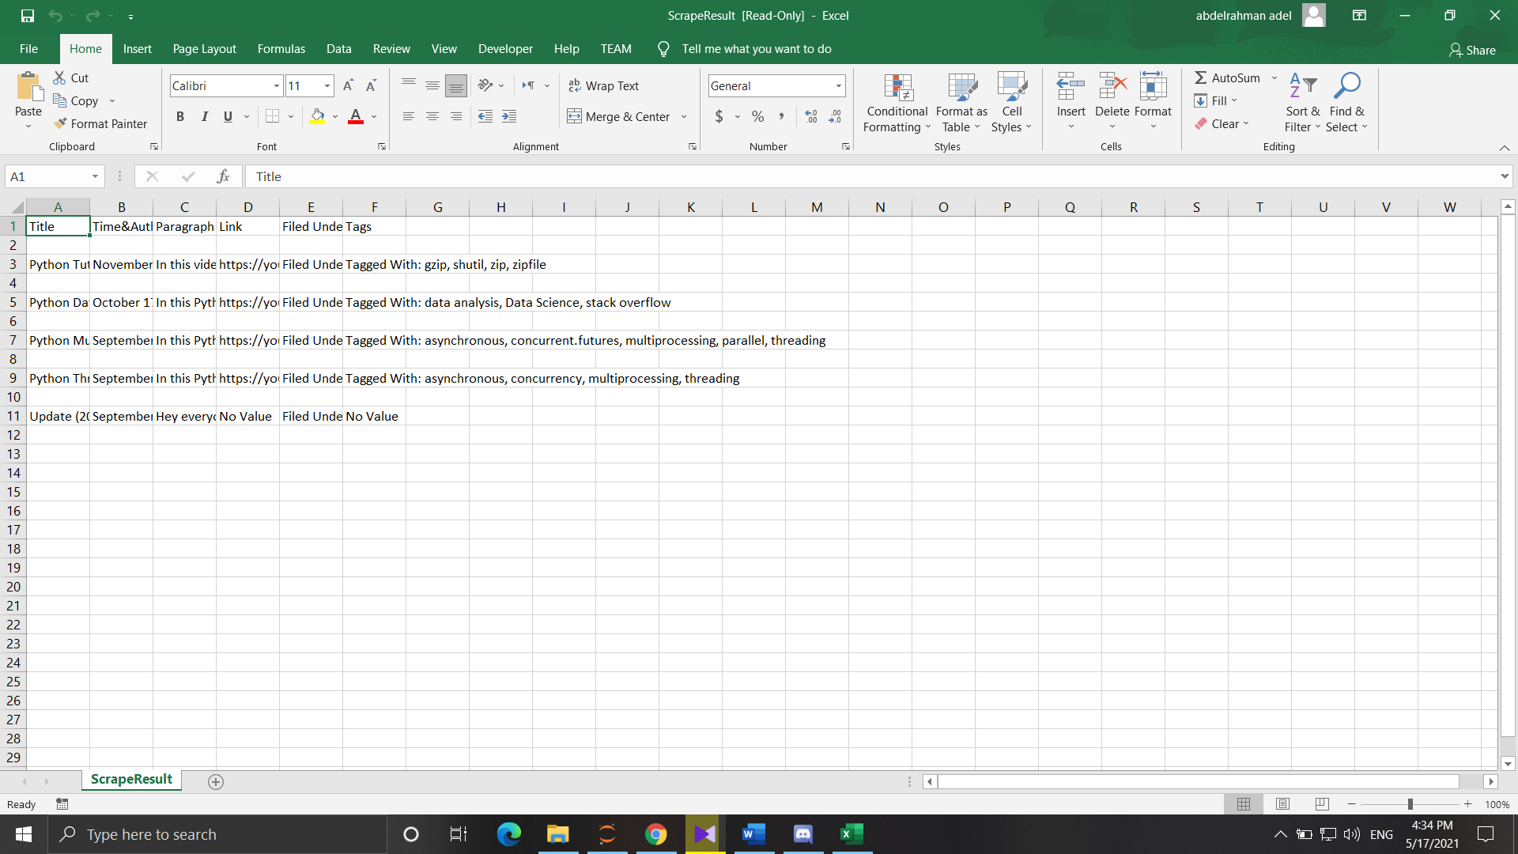

# Task Two:

Calculating the mode of data values, and how many times did it appear in the data, also the percentage of its appearance to the total data count.

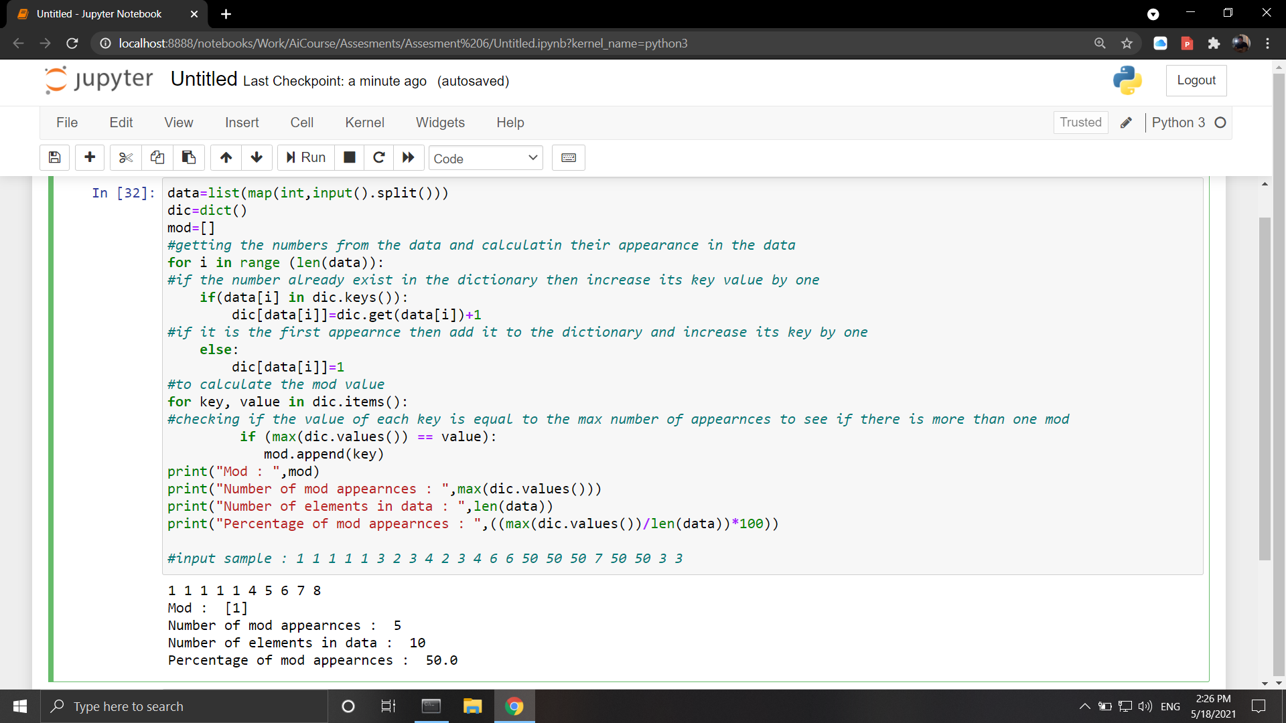

# Task Three:

Solving the html exercises on the website: <https://www.w3schools.com/html/exercise.asp?filename=exercise_html_attributes1>

